* Amazon **S3** has a simple web services interface that you can use to store and retrieve any amount of data, at any time, from anywhere on the web. It gives any developer access to the same highly scalable, reliable, fast, inexpensive data storage infrastructure that Amazon uses to run its own global network of web sites.
* S3 is not region based.
* S3 is object-based i.e it allows you to upload files.
* Not suitable to install an O/S, only for file.
* There is unlimited storage.
* Files can be from 0 to 5TB.
* S3 buckets have unique/universal name space. Ex: https://s3-eu-west-1.amazonaws.com/bucketname
* Will receive a “HTTP 200” code if upload is successful.
* **Amazon Machine Images (AWS AMI) offers two types of virtualization: Paravirtual (PV) and Hardware Virtual Machine (HVM).**

**Data consistency model of s3:**

* Read after write consistency for puts of new objects.
* Eventual consistency for overwrite put and deletes(can take some time to propagate).

**S3-Storage Classes:**

* S3 standard: High availability, durability, stored across multiple devices, no retrieval fee for s3 standard.
* S3-IA: infrequently accessed, but requires rapid access when needed. Lower fee than S3 standard but charged for retrieval fee.
* S3 One Zone-IA: lower-cost and infrequently accessed data, but available in one zone.
* Glacier: Used for data archival only, very cheap and it you don’t care about retrieval time then you can choose glacier.

**Will be charged for:** storage, number of requests, storage management pricing(when you upload an object or file to s3 you have an ability to tag, you are being charged for tagging), data transfer pricing, transfer acceleration.

**Transfer acceleration** enables fast, easy and secure transfer of files over long distance b/w you, end users and on s3 buckets. It generally users Cloud front (CDN).

**How to make an object public?**

By default bucket and the object in the bucket are private, we need to make it public. Select the object- then “action” – then click “make public”. If it fails, go back and select the bucket and click “Edit public access settings” and the uncheck all the options and then type confirm and save it.

**Encryption:-** 1) Client Side Encryption

2) server side encryption

* Server side encryption with Amazon s3 managed key(SSE-S3)
* Server side encryption with KMS(SSE-KMS)
* Server side encryption with Customer provided key(SSE-C)

**Properties of Bucket**

**Versioning:**

* Use versioning to store multiple versions of an object in one bucket (including all writes and even if you delete an object). Great backup tool, once enabled versioning can’t be disabled can only be suspended.
* Versioning’s MFA delete capability, which uses Multi-factor authentication, can be used to provide an additional layer of security.
* Integrates with lifecycle rule.

**S3 Transfer Acceleration:**

* S3 transfer acceleration utilises the cloudfront edge network to accelerate your uploads to s3. You can use a distinct URL to upload directly to an edge location which will then transfer that file to s3. You will get a distinct URL to upload to;

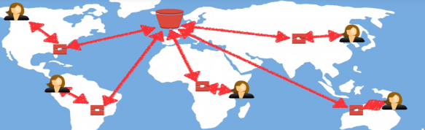

Events:

Requester Pays:

Object lock:

Object-level loggings:

Server access logging:

**Cross region replication:**

* Cross-region replication allows you to asynchronously replicate all new objects in the source bucket in one region to a target bucket in another region.
* Bucket🡪management🡪replication🡪Get started🡪Set source, replicate objects encryption with aws KMS🡪next🡪Destination bucket,options🡪IAM role🡪next🡪save
* Versioning must be enabled on both the source and destination buckets, regions must be unique as its a cross region replication.
* When you upload and create or modify files in your original bucket, changes are replicated automatically to your cross-region replication buckets, but if you go and do any deletion(deleting a file or a version of file) that is not going to replicate on to your cross-region replication buckets.
* You can’t replicate to multiple buckets.
* Files in an existing bucket are not replicated automatically. All subsequent updated files will be replicated automatically. To Copy existing files from one bucket to another in CLI:- Aws s3 cp –recursive s3://[target bucker name] s3://[destination bucket name]

**Lifecycle Management, S3-IA & Glacier:**

* Bucket🡪Management🡪Lifecycle🡪Add lifecycle rule🡪Enter rule name,next,configure transition,next,configure expiration,next,save
* Can be applied to current and previous version.

**Cloud Front(CDN):**

* Edge Loccation: This is the location where content will be cached. This is separated to an AWS region/AZ
* Distribution: this is the name given to CDN which consists of a collection of edge locations.

🡪Web distribution – Typically used for websites.

🡪RTMP – used for media streaming.

* Objects are cached for the life of the TTL(Time to Live)
* You can clear cached objects, but you will be charged.

**Storage Gateway:**

* AWS Storage Gateway is a service that connects an On-Premises software appliance with cloud-based storage to provide seamless and secure integration between an organization’s on-premises IT environment and aws storage infrastructure.
* AWS storage gateway’s software appliance is available for download as a virtual machine image that you install on a host in your datacenter. Once you’ve installed your gateway and associated it with your aws account through the activation process, you can use the aws management console to create the storage gateway option that is right for you.

Types of gateway:

🡪File gateway(NFS): files are stored as objects in your s3 buckets, accessed through a NFS, for files

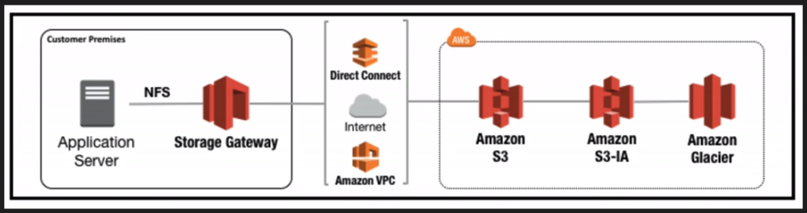

🡪Volumes Gateway(iscsl)

🡪stored volumes: Entire dataset is stored on site and is backed up to s3.

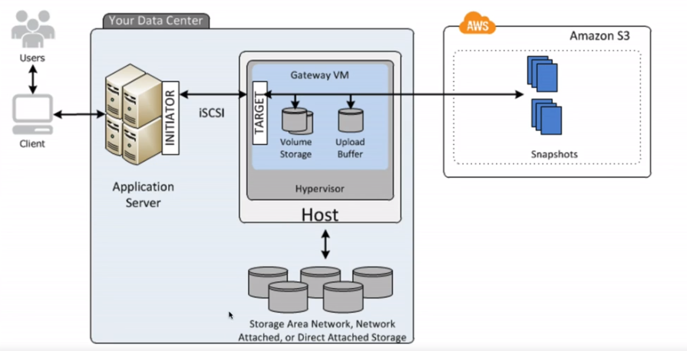

🡪cached volumes: Entire dataset is stored on s3 and the most frequently accessed data is cached on site.

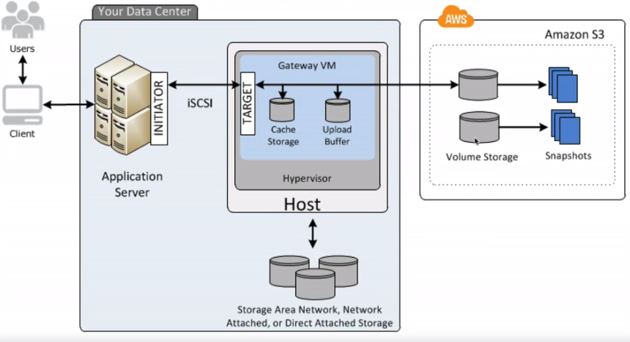

🡪Tape Gateway (VTL): Used for backup and users popular backup applications.

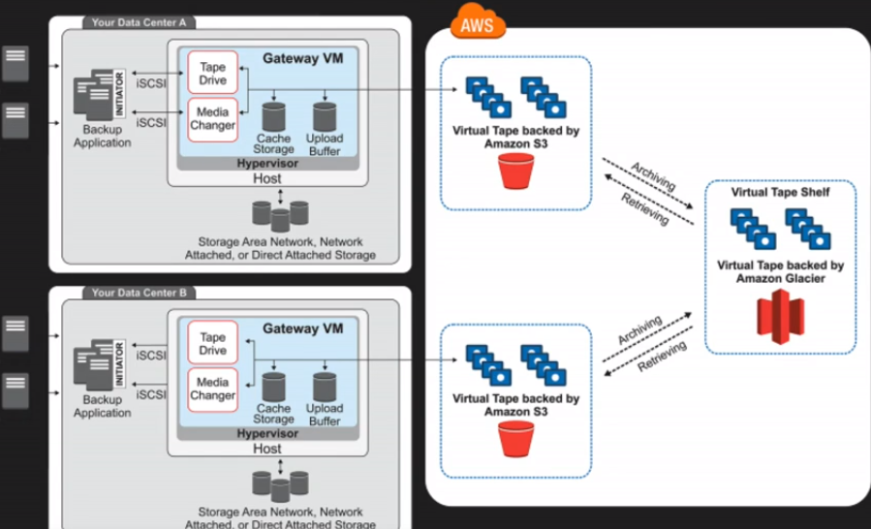

Create A Static websight using S3:

{

"Version":"2012-10-17",

"Statement":[

{

"Sid":"AddCannedAcl",

"Effect":"Allow",

"Principal": {"AWS": ["arn:aws:iam::111122223333:root","arn:aws:iam::444455556666:root"]},

"Action":["s3:PutObject","s3:PutObjectAcl"],

"Resource":["arn:aws:s3:::*examplebucket*/*"],

"Condition":{"StringEquals":{"s3:x-amz-acl":["public-read"]}}

}

]

}